**Big Data Video Presentation**

**Question d:**

**Uploading CSV in S3**

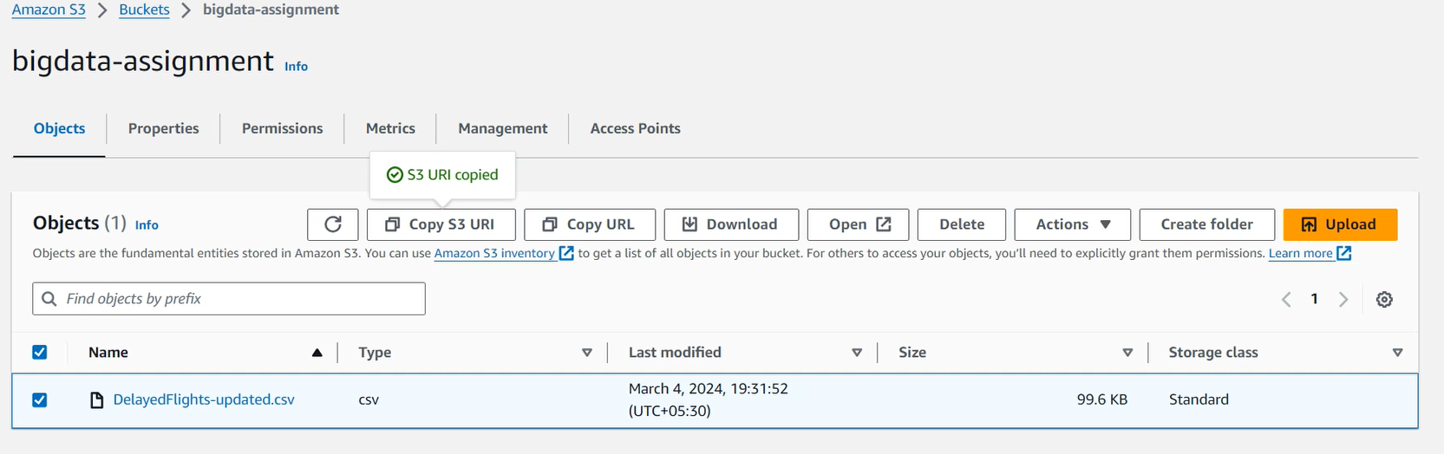

**Spark Initialization**

**Spark Code**  
from pyspark.sql import SparkSession

# Create a Spark session

spark = SparkSession.builder.appName("DelayFlightsAnalysis").getOrCreate()

# Upload CSV and create DataFrame

csv_path = "path/to/DelayedFlights-updated.csv"

delay_flights_df = spark.read.csv(csv_path, header=True, inferSchema=True)

# Create a temporary table named delay_flights

delay_flights_df.createOrReplaceTempView("delay_flights")

# Run the first query using HiveQL

result_hiveql = spark.sql("""

SELECT Year, AVG((CarrierDelay / ArrDelay) * 100) AS avg_delay_percentage

FROM delay_flights

GROUP BY Year""").show()

# Run the second query using Spark SQL

result_sparksql = spark.sql("""

SELECT Year, AVG((CarrierDelay / ArrDelay) * 100) AS avg_delay_percentage

FROM delay_flights

GROUP BY Year""").show()

**Question e:**

**EMR Cluster Initialization**

**Adding Shell Script and table in Hadoop directory**



**Grant permission to Shell Script and execute**



**Map Reducer Worker distribution**



**Run Time Calculation**

**Download into local path**



**Results**

### Shell Script file is [**assignment_for_5_iteration.sh**](https://github.com/TuanMinhajSeedin/UoM_MapReduce-vs-Spark/blob/main/assignment_for_5_iteration.sh)

**Question f:**

### **Same command approach as above. But Shell script is different. I have attached it in the same folder** [assignment_for_5_queries.sh](https://github.com/TuanMinhajSeedin/UoM_MapReduce-vs-Spark/blob/main/assignment_for_5_queries.sh)

**Results**

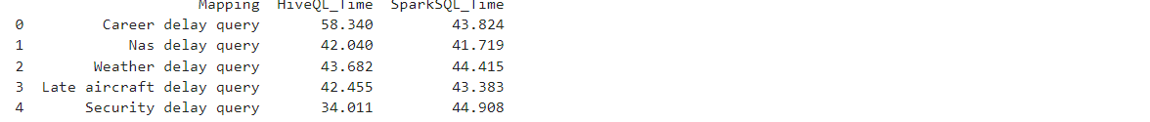

**Question g:**

**Results**

